Biomedical Applications of 2-Cyanoacrylates Stephen J. Hynes, PhD, Biomedical Product Development,
Henkel Technology Centre Europe, Tallaght Business Park, Dublin 24.
(stephen.hynes@ie.henkel.com)

Introduction
Among the wide variety of synthetic polymers with medical applications polymerising medical devices are those non-pharmaceutical medical aids which are based on monomers which can be polymerised after (or during) application to the body. The resultant polymers perform roles in wound management, repair, stabilisation and hemostasis. They can also support tissue re-growth, as well as being used for drug delivery. The synthetic systems most commonly used are based around acrylic ester chemistries, analogous to their non-medical uses as plastics and adhesives.

Acrylate and methacrylate esters are olefinic monomers, which undergo radical or redox -initiated polymerisation and have many medical applications. For example in the areas of bone and dental cements, polymethylmethacrylate (PMMA) is used as a two-part mixture of monomer/stabiliser and pre-polymer/initiator which undergoes radical-initiated polymerisation upon mixing. This can be used as an aid to anchoring prosthetic joints, such as hip replacements and as a bone filler.
Figure 1. Useful acrylate monomers

2-Cyanoacrylates
2-Cyanoacrylates are related monomers that are the main constituents of the well known ‘Superglue’ instant adhesives. They are also used extensively as medical devices however the applications differ from acrylate and methacrylates due to the differing chemistries of the monomers. It is the biomedical applications of these 2-Cyanoacrylates (CAs) which will form the basis of this discussion.

History
Ardis patented alkyl-2-cyanoacrylates as adhesives in 1949. However it was not until the 1960’s that suitable synthetic procedures were developed to isolate and stabilise the monomer. The most important feature of 2-cyanoacrylates is their spontaneous and rapid polymerisation in seconds at room temperature particularly when placed between two surfaces. This allied to their excellent ‘wetting’ ability and low viscosity results in a strong adhesive bond when applied to most surfaces. They are thus invaluable as structural adhesives to virtually every industry with many different formulations and monomers tailored to suit each application. Ethyl-2 cyanoacrylate has found the most notoriety as the SuperGlue® consumer adhesives.
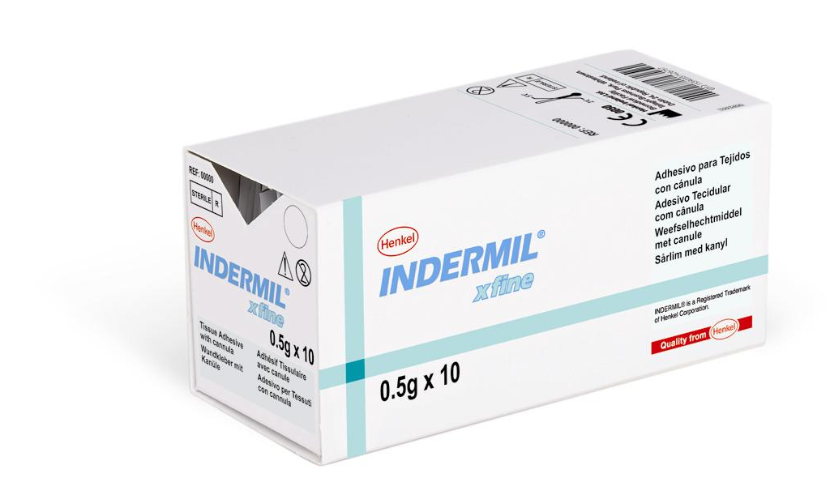
Figure 2. Indermil® Tissue Adhesive: Designed, developed and manufactured in Ireland.

In an interesting Irish angle to the cyanoacrylate story some of the important work to elucidate the mechanism of polymerisation of CAs was completed at Trinity College Dublin by Prof. D.C. Pepper (see ref. 8) and more recent investigations have been carried out at the University of Limerick. Also many of the early formulations for consumer and industrial applications were developed in Dublin at Loctite (now Henkel) An example of the strength of these superglue bonds was displayed recently by the suspending of a ‘world record’ 5 ton load from an adhesive bond made from just nine drops of Ethyl CA based adhesive.

Chemistry
Cyanoacrylates are generally synthesised by the base-catalysed Knoevenagel condensation of cyanoacetates with formaldehyde. The water produced is removed by azeotrope and the resulting oligomers are ‘cracked’ at high temperatures to free the monomer, 1 (Scheme 1) which is then distilled on to a mixture of stabilisers. The monomer is redistilled to purity and can be stored for long periods in the refrigerator.

Scheme 1. Knoevenagel Condensation of cyanoacetates with formaldehyde.

The polymerisation mechanism is usually anionic/zwitterionic in nature and can be initiated by trace amounts of almost any nucleophile (< 1ppm in unstabilised CA) including water, alcohols, phosphanes and ammonium salts. Termination is due to the presence of a cation, usually a strong acid. Otherwise the polymerisation continues until the monomer supply is exhausted in the manner of a ‘living polymer’ – polymerisation can be reinitiated by addition of more monomer. A strong exotherm is produced due to the rapid nature of the polymerisation. There is also a radical-promoted mechanism for polymerisation similar to other acrylates. Cyanoacrylates must be mixed with appropriate acidic stabilisers (usually SO₂ or BF₃) and radical stabilisers (e.g. hydroquinone) to prevent polymerisation during storage. Their low viscosity (similar to water) means thickeners are employed in most formulations.
Scheme 2. Anionic Polymerisation of 2-Cyanoacrylate

Cyanoacrylates in medicine

Tissue adhesives
There are three general routes to the closure of surgical incisions or wounds - stapling, suturing or adhesive bonding. Suturing and stapling can be painful to the patient and normally require the use of an anaesthetic. Anyone who has ever used superglue can testify to its ability as a skin bonder. It is in this area that cyanoacrylates found their initial medical application as tissue adhesives for wound closure., CAs hold several advantages over other tissue adhesives such as fibrin and collagen glues. These include cost, faster cure rates, spontaneous curing without initiation under physiological conditions and stronger bond formation. Cyanoacrylates also possess some antimicrobial properties, which help prevent post-procedure wound infection without antibiotics. CA tissue adhesives are one-treatment, pain free wound closing medical devices and are increasingly common both in surgical and A&E environments.

Historically their first medical use was to prevent blood loss in field hospitals during the Vietnam War. However, subsequent trials with the commonly used consumer and industrial monomers (ethyl- and methyl-CA) failed to gain regulatory approval due to instances of tissue necrosis and inflammation in clinical trial patients. These reactions were ascribed to the toxic by-products of biodegradation in vivo. CA degradation pathways have been investigated both in vivo and in vitro. Two pathways have been proposed, which are thought to work in concert. First is the random hydrolytic chain scission, leading to inverse Knoevenagel condensation and formaldehyde formation. The second is cleavage of the ester linkage (both enzymatic and hydrolytic) to afford water-soluble acid residues and alcohols. ,, The combination allows bio-absorption and excretion of the component parts, but the associated by-products, particularly formaldehyde, cause the adverse tissue reactions.

The tissue response to biodegradable materials is regulated by the toxicity of the degradation products and the rate of degradation of the polymer. In the case of CAs, the rate of degradation of polymers with longer chain alkyl groups is much slower when compared to methyl or ethyl derivatives. The slower degradation rate results in slower release of formaldehyde, or other toxic by-products such as alcohols. This allows their removal by natural systems resulting in a reduced tissue response. However, this slower rate of degradation results in the presence of the polymer long after wound healing is complete. The lack of degradation of such polymers in vivo can result in other complications, such as tissue necrosis and foreign-body giant cell reaction. This has obvious implications for internal applications of CAs. However, development of these longer-chain analogues did lead to the FDA approval of CAs as topical tissue adhesives in 1998 as the residual CA sloughs off the skin surface. CA’s have been approved for use as topical tissue adhesives in Europe and Canada since the 1970’s. Internal applications of CA are still rare.

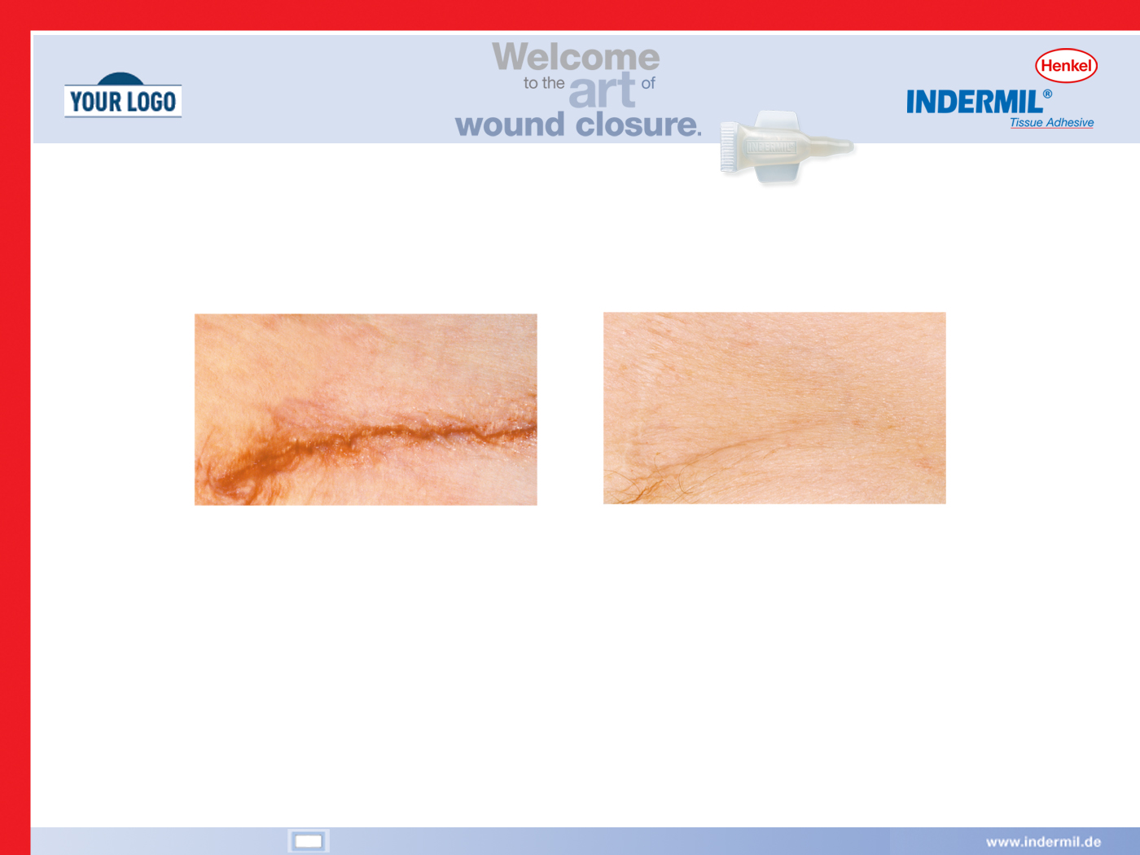
a)
b)
Figure 3. Wound closure with minimal scarring using cyanoacrylate adhesive at a) day of closure and b) three months after closure.

Sterilisation of Cyanoacrylates for Medical Use
The sterilisation of medical devices is an important requirement and poses interesting issues for CAs due to their relative instability. Indeed, most sterilisation methods would promote polymerisation of the monomer. These problems have been overcome by careful selection of stabilisers and packaging materials to protect the monomer. Tissue adhesives available on the market have been sterilised by filtration, heat, e-beam and gamma radiation.

Internal cyanoacrylate applications
As mentioned above due to the poor degradation rate of long chain alkyl-2-cyanoacrylates are not commonly approved for internal use. However there are a number of surgical procedures where they have been used “off-label”

- Sclerotherapy
Sclerotherapy is the closure of varices (distended veins). The procedure may be cosmetic (varicose veins) or lifesaving (bleeding intestinal or oesophageal varices). Sclerotherapeutic methods involve the injection of the agent (sclerosant) into the vein causing thrombosis or fibrosis and ultimately destruction of the venous channel. The procedure is common in Europe and Asia but less so in the US. 2-Cyanoacrylates such as Histoacryl are among the agents which have been successfully employed in this procedure.

- Surgical sealants
An attractive potential use for CA is as surgical sealants during operations. Again due to toxological issues this has not found favour generally. However the advantages over suturing or stapling are even more obvious than for topical applications as demonstrated by Lumsden and coworkers.

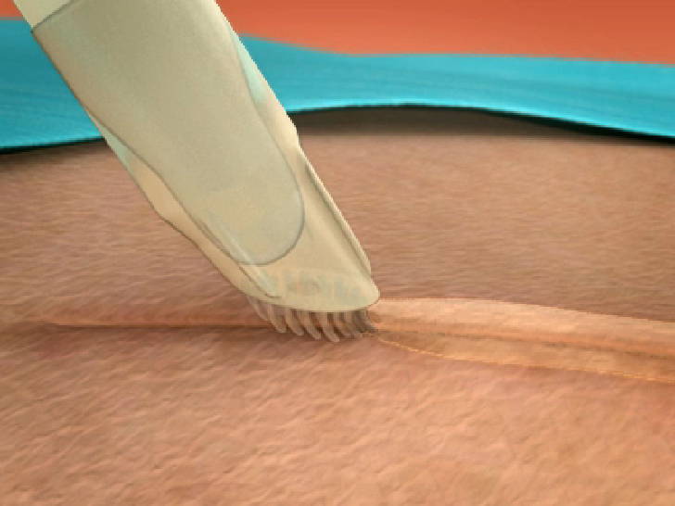
Figure 4. Topical Application of Tissue Adhesive – adhesive is placed on top of the skin and not into the wound.

Current and Future Research
As shown the current medical market for CAs is mainly based around topical (skin) tissue adhesives. A push to advance the technology to internal applications has been hampered by the unsuitability of the degradation rate of the existing monomers. Thus in more recent years there has been much interest in generating new monomers and formulations which modify the rate of absorption of the polymer or the reduce the effects of the toxic by-products.

Given the limited scope for changing the basic structure of the cyanoacrylate monomer, research on novel biodegradable cyanoacrylates has focused on two areas. Firstly, increasing the hydrophilicity of the alkyl side chain, thereby altering its rate of in vivo degradation, and secondly, incorporating degradable polymer chains into the adhesive formulation to increase flexibility and degradation rate of the resulting polymer matrix. On the first approach, alkoxyalkyl monomers 2 have proved to be much more degradable than higher alkyl chain monomers such as butyl-CA, 3-methoxybutyl has been shown to be one of the most promising of these alternatives, with a degradation rate greater than that of n-butyl CA but with lower levels of tissue response. Alternative examples include 1,2-glyceryl 2-cyanoacrylate 3, which replaces the alkyl chain with a glycerol ketal moiety. This rapidly degrades under physiological conditions to afford glycerol and acetone, both of which are non-toxic metabolites. Bond strength of the adhesive exceeded that required for tissue adhesives.
Figure 5. Biodegradable CAs

Secondly, there have been several recent patents aimed at increasing the biodegradability of cyanoacrylate-based adhesives by incorporating polymeric fragments into CA formulations. The majority of these have focused on using copolymers of common bio-absorbable materials. These provide both the increased flexibility and degradability of the polymer bond without significantly reducing bond strength. These polymeric fragments are generally polyester in nature, formed from mixtures of lactide, glycolide, ε-caprolactone, trimethylene carbonate, and p-dioxanone. Polyoxalate and PEG based formulations have also been reported.

These innovations have shown great promise however none have thus far made it to the marketplace.

Cyanoacrylate nanoparticles as Drug Delivery Systems
The desire for targeted drug delivery arises from the inefficiency of current chemotherapeutic methods, which result in poor selectivity and unwanted side effects. Increased drug resistance, the need for control of the release rate of the active agent into the bloodstream and protection of pharmaceutical agents sensitive to adverse physiological conditions prior to uptake by the target tissues have all heightened the search for ways to disguise existing drug molecules from cell and microbial defences and enhance their efficacy. Drug-containing nanoparticles have been seen as a possible way to accomplish this by encapsulating the drug in a suitable degradable shell. Many colloidal systems have been tested as vehicles for targeted delivery, such as liposomes and biodegradable polymers. Polyalkylcyanoacrylate (PACA) nanoparticles first emerged as drug delivery candidates in the early 1980s. Their ease of polymerisation in water, facile encapsulation of a wide variety of drug products, the biodegradability of the nanoparticles and relatively low toxicity in vivo have made them among the most popular substrates in this large and expanding area of medical research. An example of the spectacular results that can be obtained using PACA nanoparticles can be found in cancer therapeutics. Couvreur and co-workers dramatically enhanced the efficacy of doxorubicin. Association with PACA nanoparticles reduced the IC₅₀ of doxorubicin for normally resistant breast cancer cells by a factor of 130 These doxorubicin–PACA nanoparticles have undergone clinical trials. Cytotoxicity studies have shown that the make-up of the monomer side-chain of these nanoparticles influences their toxicity at the cellular level in the same way as described for tissue adhesives above i.e. that cells display increased sensitivity to nanoparticles of monomers with shorter chain length whereas those of longer chain length are less toxic, again due to the slower rate of degradation. However there are issues with long-term effects on the cell of the virtually non-degradable long chain esters such as 2-octyl CA. The make-up of the nanoparticle can also determine the level of absorption by a particular tissue; this has implications for cytotoxicity of the nanoparticle and accuracy of targeting with the pharmaceutical agent. Recent research has included coating the CA nanoparticles with biodegradable materials such as dextran to improve tolerance and targeting of tissues.
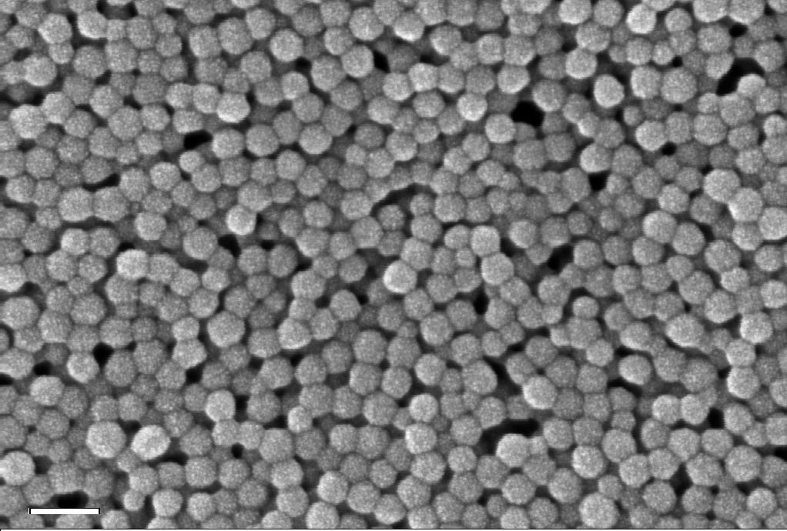
Figure 6. SEM image of PIBCA nanoparticles prepared by anionic emulsion polymerization (the scale bar represents 100nm).

Future potential
One of the main inhibitors to the generation of new CA monomers for biomedical applications is the method of synthesising the CA itself. As described above the conditions required are relatively harsh with temperatures of up to 200ºC required to thermally depolymerise the intermediate oligomer to afford the monomer. Also the monomer must be distilled in the presence strong acid to purify. Thus it is impossible to use the standard method to synthesise CAs with side chains of high molecular weight and/or those containing thermal- or acid-sensitive functional groups. There are several other methods which can be used to synthesise unusual CAs, most notably via ‘protection’ of the sensitive methylene group as a
Scheme 3. Transesterification of Ethyl CA via a Diels-Alder adduct.

Diels–Alder adduct and subsequent transesterification followed by ‘deprotection’ using a superior dienophile such as maleic anhydride.

Some patents detail methods to generate cyanoacrylic acid and esterify with an appropriate alcohols usually via the acid chloride. However it is not commercially practical to use any of these methods to synthesise CAs. This dramatically limits the pool of structures available. From this point of view a new method of CA synthesis recently developed at Henkel, Dublin may go some way to improving the scope of structures available for biomedical purposes. Using iminium-ion based ionic liquids generated from formaldehyde and a high boiling amine and an organic acid the Knoevenagel reaction can be carried with rapid distillation of the monomer without the need to depolymerise an oligomer. This and other methods under development should allow the synthesis of monomers which can expand the range of applications of CAs in medicine.
Scheme 4. Synthesis of CA via ionic-liquid intermediate.

As we have shown Alkyl 2-cyanoacrylates perform an important role in medicine as rapid setting tissue adhesives. Their unique properties have made them an attractive alternative to sutures or staples as a method of topical wound closure. There is still scope for improvement however, to expand the application of these useful medical devices to the field of internal medicine where their unique advantages over other methods of wound closure would be further enhanced. CAs are still the subject of a large amount of interest in the area of targeted drug delivery. Further development in both of these areas depends on obtaining new monomers with novel functionalities which enhance the biocompatibility of the technology.

Acknowledgements
Thanks to Dr. Kenneth Broadley for useful discussion regarding content and Dr. C. Vauthier who supplied the SEM image of the PACA nanoparticles.

References

For reviews see, Biomaterials Science 2nd Ed, 2004, Academic Press, Ratner et al, ISBN-10: 0125824637
S.M. Kenney and M. Buggy J. Mat. Sci: Mat. In Med 2003, 14, 11, 923.
A. Ardis US patent, 2,467,926 (1949)
For reviews of Cyanoacrylate adhesives and their applications see: G.H. Millet in Structural Adhesives Plenum Press S.R. Hartshorn, Ed. ISBN 0-306-42121-6; Y.G. Gololobov and W. Gruber, Russ. Chem. Rev. 1997, 66, 11, 953.
N. Behan and C. Birkinshaw, Macromol. Rap. Commun. 2000, 21, (13), 884; N. Behan, C. Birkinshaw and N. Clarke, Biomaterials, 2001, 2, 11, 1335.
See: US Patent Application 3,699,127 (1972), US Patent Application 3,742,018 (1973), US Patent Application 4,038,345 (1977), US Patent Application 4,105,715 (1978)
http://www.rte.ie/news/2009/0427/glue.html ‘ World Record for Dublin adhesive maufacturer’
D.C. Pepper and B. Ryan, Makromol. Chem. 1983, 184, 383; G. Costa, C. Loonan and D.C. Pepper, Makromol. Rapid Commun. 1997, 18, 891; D.C. Pepper and D.S. Johnson, Makromol. Chem. 1981, 182, 393; D.C. Pepper and D.S. Johnson, Makromol. Chem. 1981, 182, 407; D.C. Pepper and D.S. Johnson, Makromol. Chem. 1981, 182, 421; D.C. Pepper, Poly. J. 1980, 12, 629.
See ref 4.
US Patent 3,359,264 (1973)
F. Leonard, R. Kulkarni, J. Nelson and G. Brandes, J. Biomed. Mater. Res. 1967, 1, 3.
R. Eiferman and S. Snyder, J. Arch. Ophthalmol. 1983, 101, 958.
F. Leonard, R.A. Kulkarni, G. Brandes, J. Nelson and J.J. Cameron, J. Appl. Polym. Sci. 1966, 10, 259; R.A. Kulkarni, G. Hanks, K. C. Pani and F. Leonard, J. Biomed. Mater. Res. 1967, 1, 11.
W.R. Vezin and A.T. Florence, J. Biomed. Mater. Res. 1980, 14, 93.
C. O’Sullivan and C. Birkinshaw, Biomaterials, 2004, 25, 4375.
C. Vauthier, C. Dubernet, E. Fattal, H. Pinto-Alphandary and P. Couvreur, Advanced Drug Delivery Rev. 2003, 55, 519.
C. Wade and F. Leonard, J. Biomed. Mater. Res. 1972, 6, 215.
K.C. Pani, G. Gladieux, R.A. Kulkarni and F. Leonard, Surgery 1968, 63, 3, 481.
FDA guideline, 26August 1998
B.U. Wu and D.L. Carr-Locke MedGenMed. 2006; 8(3): 72; S. Hyo and M.H. Young, Kor. J. Radiol. 2008 9(6), 526.
A.B. Lumsden and E.R. Heyman, J. Vas. Surg. 2006, 44, 5, 1002.
A.M. Henderson and M. Stephenson, Biomaterials 1992, 13, 15, 1077.
H. Jaffe, C.W.R. Wade, A.F. Hegyeli, R.M. Rice and J. Hodge, J. Biomed. Mater. Res. 1986, 20, 213.
S.W. Shalaby, US Patent. 6,723,114 (2004); S.W. Shalaby, US Patent. 5,350,798 (1994); D. Kotzev, US Patent. 6,797,107 (2004)
C. Linden and S.W.Shalaby, J. Biomed. Mater. Res. (Appl. Biomater.) 1997, 38, 348.
For reviews see: L. Brannon-Peppas, Int. J. Pharmaceutics 1995, 116, 1; J. Panyam V. Labhasetwar, Adv. Drug Delivery Rev. 2003, 55, 3, 329.
P. Couvreur, M. Roland and P. Speiser, US Patent, 4,329,332, (1982).
C. O'Sullivan, and C. Birkinshaw, Polymer Degrad. and Stab., 2002 78, (1),7; C. O’Sullivan, and C. Birkinshaw, Biomaterials, 2004, 25 (18), 4375.
L. Trepel, M. Poupon, P. Couvreur and Piusieux C.R., Acad. Sci. 1991, III, 313, 171.
J. Kattan, J.P. Droz, P. Couvreur, J.P.Marino, A. Boutan-Larouze, P.Rougier, P. Brault, H. Vranks, J.M. Grognet, X. Morge and H. Sancho-Garnier, Invest. New Drugs 1992, 10, 191.
C. Chauvierre, L. Leclerc, D. Labarre, M. Appel, M.C. Marden, P. Couvreur and C. Vauthier., Inter. J. Pharmaceutics 2007, 338 (1-2), 327.
Picture taken by A. Allavena-Valette, CNRS CECM, Vitry sur Seine and the particles were prepared by C. Vauthier, CNRS UMR 8612, Chatenay-Malabry.
P. Klemarczyk, Polymer 1998, 39, I, 173 and refs therein.
C. Buck, US Patent 4,012,402 (1977); J.P. Kennedy, S. Midha, and A.J. Godhari, Macromol. Sci., Chem., 1991, A28 (2), 209.
S. Takahashi, Y. Ohashi, Y. Ando, T. Okuyama, US Patent. 5,703,267 (1997)
V.A. Dyatlov, International Patent WO 1995/32183; International Patent WO 1994/15907
C. McArdle and L. Zhao, International Patent WO 2008/050313. .

